ACT Practice Resources
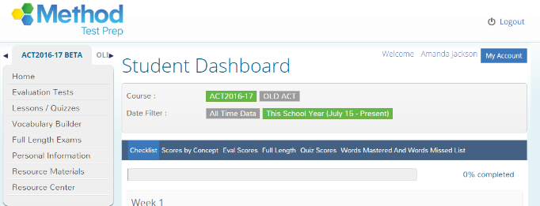
www.sdmylife.com
- Log into SDMyLife
- Lower Right side. Click Method Test Prep

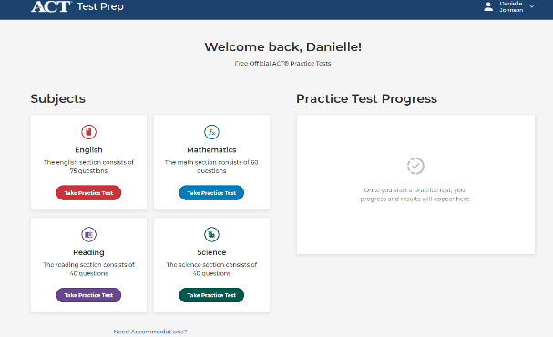
https://my.act.org/
- Creating an account:
https://success.act.org/s/article/MyACT-Quick-Start-Guide
- ACT Free Prep how to: https://www.act.org/content/dam/act/unsecured/documents/2021/ACT-Test-Prep-Practice-Test-User-Guide.pdf

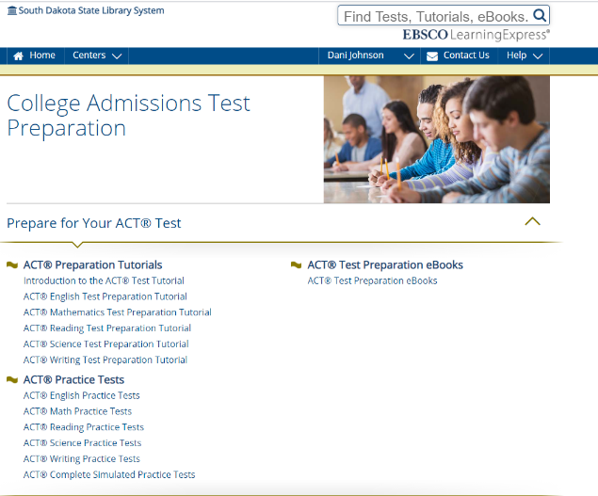
https://www.learningexpresshub.com/
Access while at school the first time to give you free access!
Sign in or Register
- “Centers” Tab
- “College Admission Test Preparation”
- “Prepare for your ACT Test”

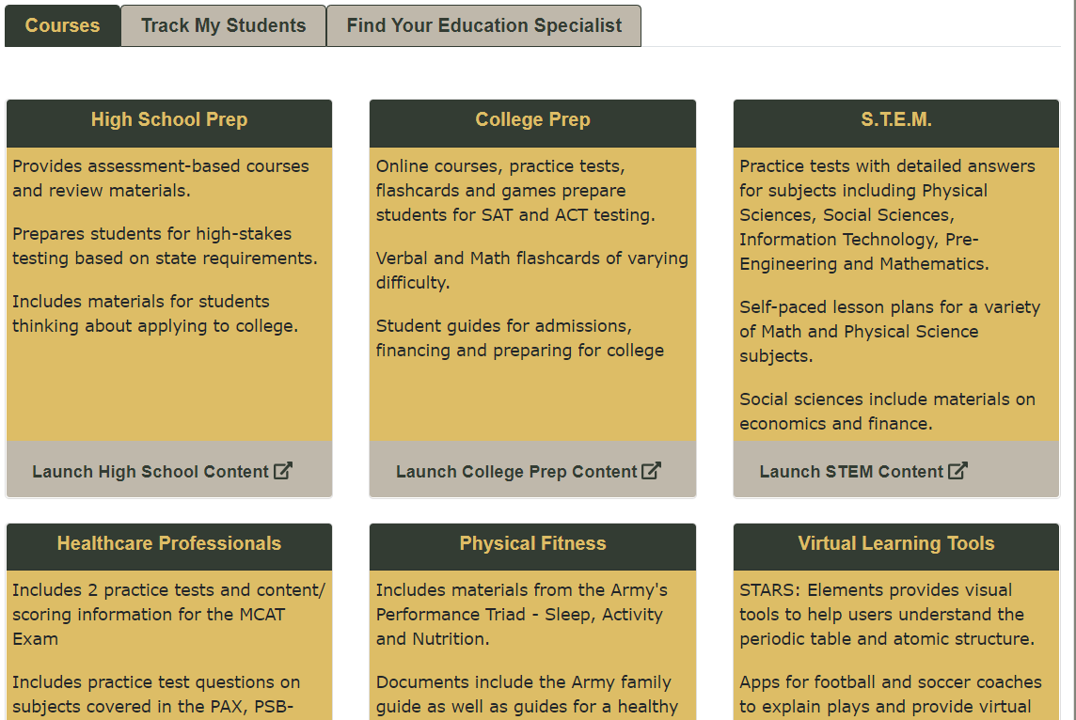
www.march2success.com
This is a free resource from the Army and has test prep/practice for the ACT, SAT, and ASVAB.
It does require the student to create a log-in but is free

Cell Phone APPS!
I love this option because you can do it anywhere, when you are bored or just have a few minutes. There are both free and paid versions. One of my favorites is ACT Prep: Practice Tests, Flashcards. Many of these apps will also send a question of the day to your phone to remind to constantly keep working on it.
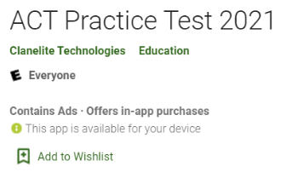
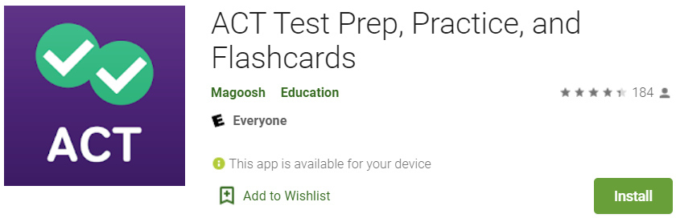
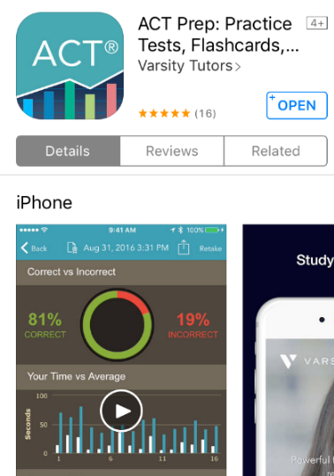
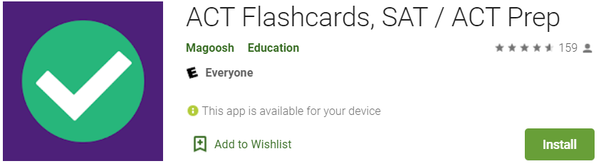

Tips for better strategies: (Here are some examples, but also look at the other suggested videos when you go to these)
Math: https://www.youtube.com/watch?v=y9zCjGHkwWM https://www.youtube.com/watch?v=YjFRchAp6MM
Reading: https://www.youtube.com/watch?v=CD4560aSfYE https://www.youtube.com/watch?v=CD4560aSfYE
English: https://www.youtube.com/watch?v=QFK3C04BZTI
Science: https://www.youtube.com/watch?v=E5ZuY1yB3XY
Writing https://www.youtube.com/watch?v=mrQYoZnctJM
- This is an optional portion but if you are going out of state for college – ASK if you need the writing portion!

Counselor’s office – has multiple practice ACT tests available for you to get copies of

https://blog.prepscholar.com/complete-official-act-practice-tests-free-links - has previous years “Preparing for the ACT test” booklet tests online

ACT Academy offers free online support - https://actacademy.act.org
http://www.eknowledge.com/SDHSAA - offers a program to prep for ACT and SAT. This one does have a cost

